Thực hành buổi 2

Tên: Lê Hoàng Huy

MSSV: CNTT2211022

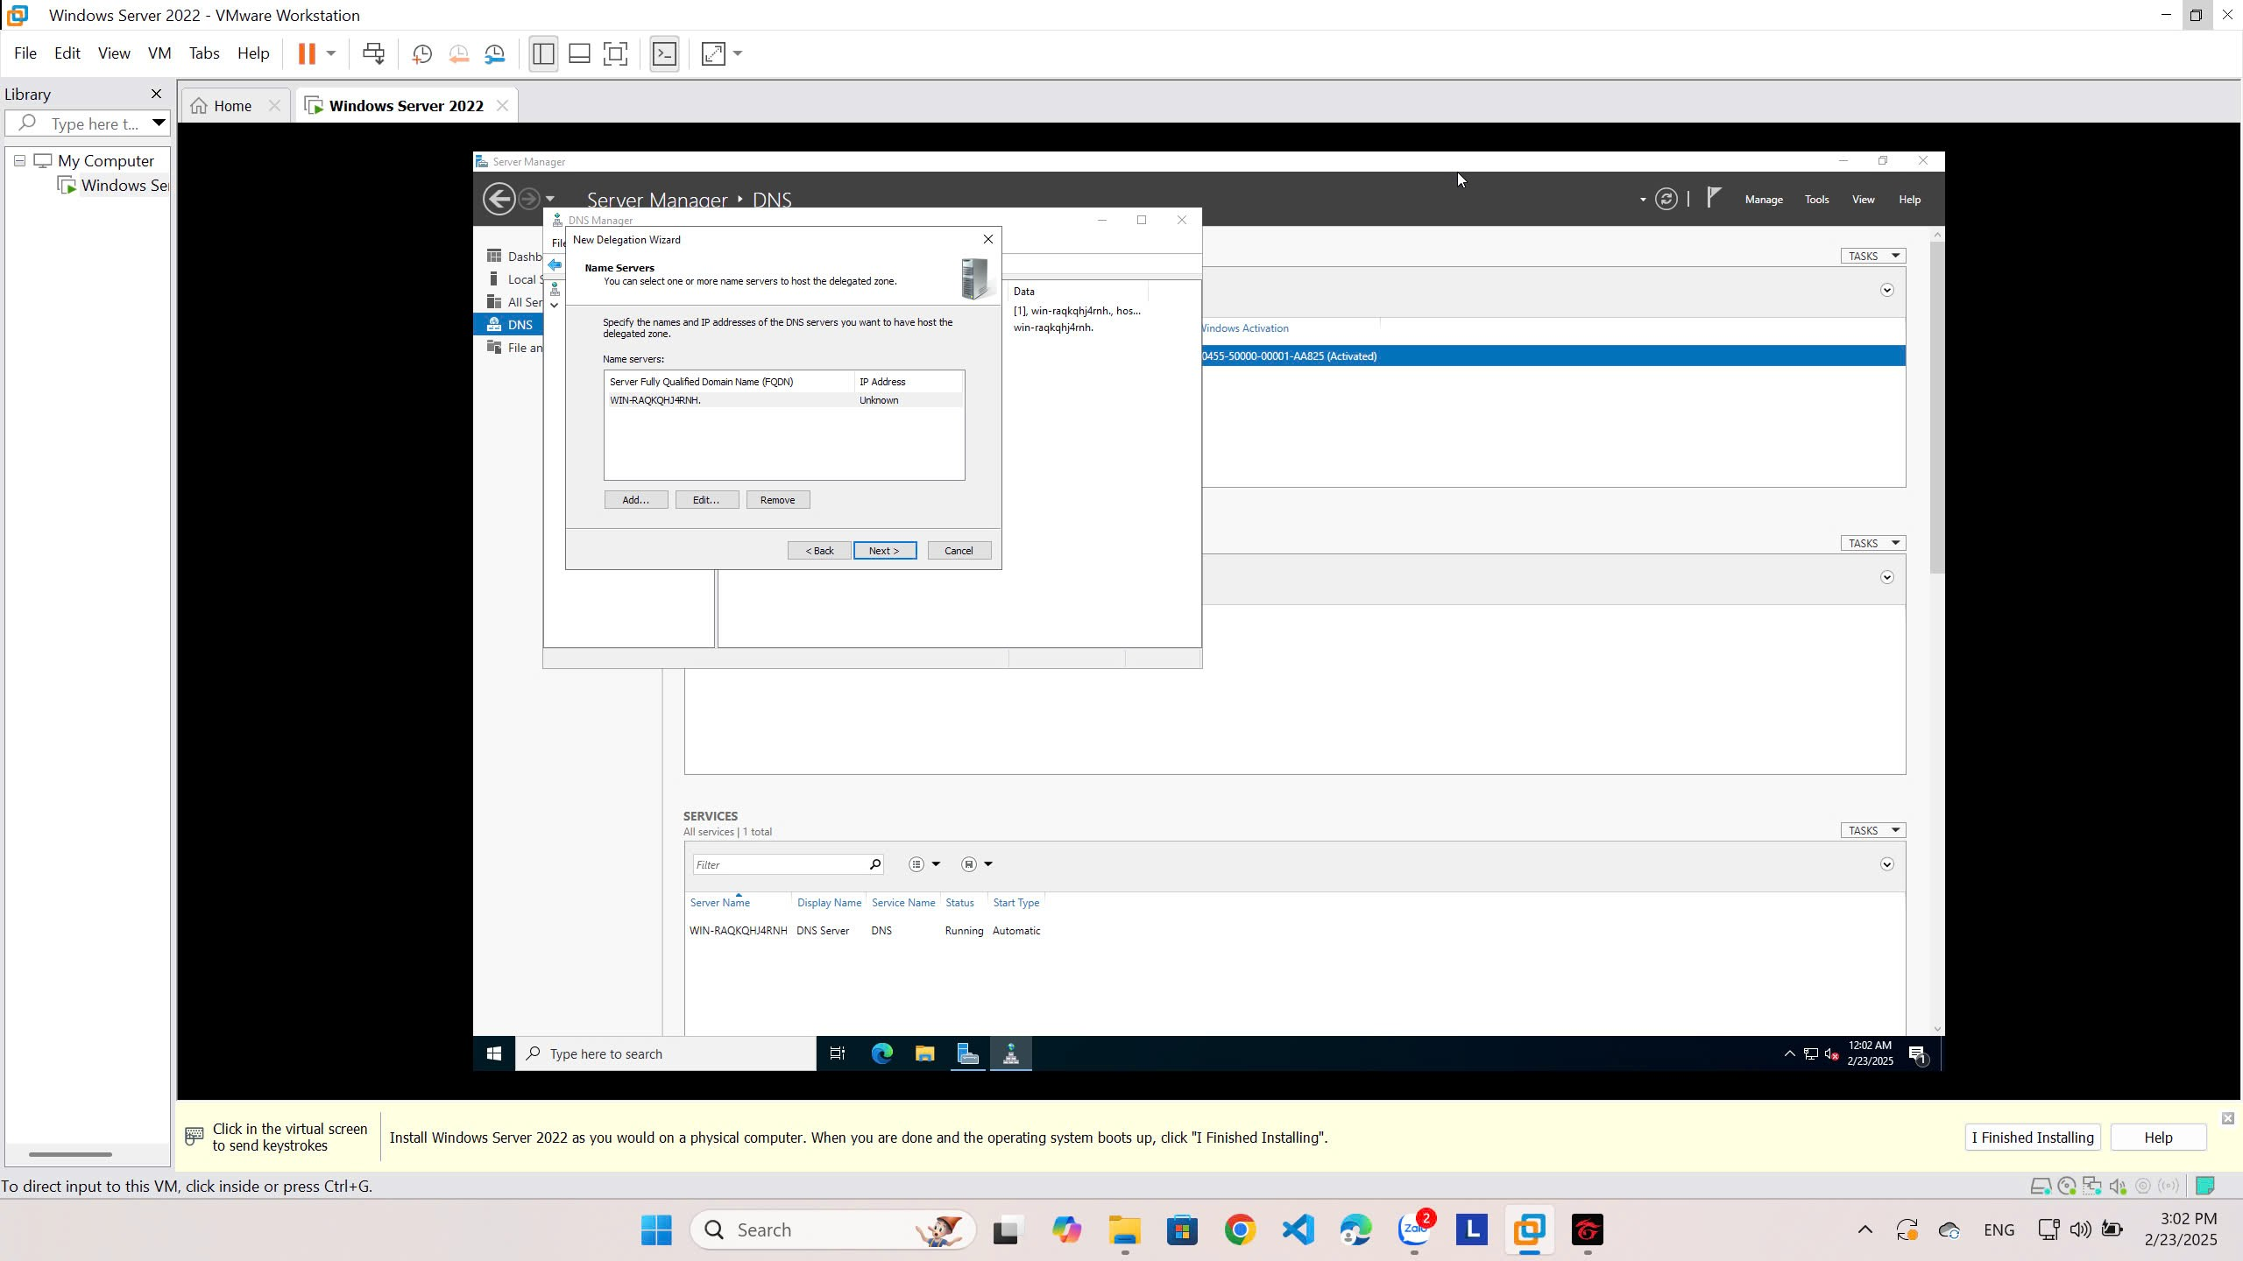

**Creating a Delegated DNS Zone**

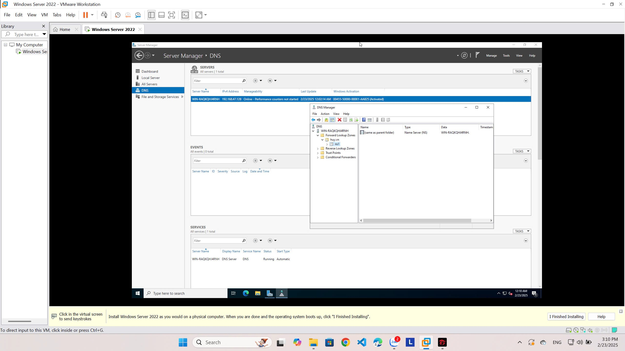

IP: 192.168.47.128

**Manually Creating DNS Records**

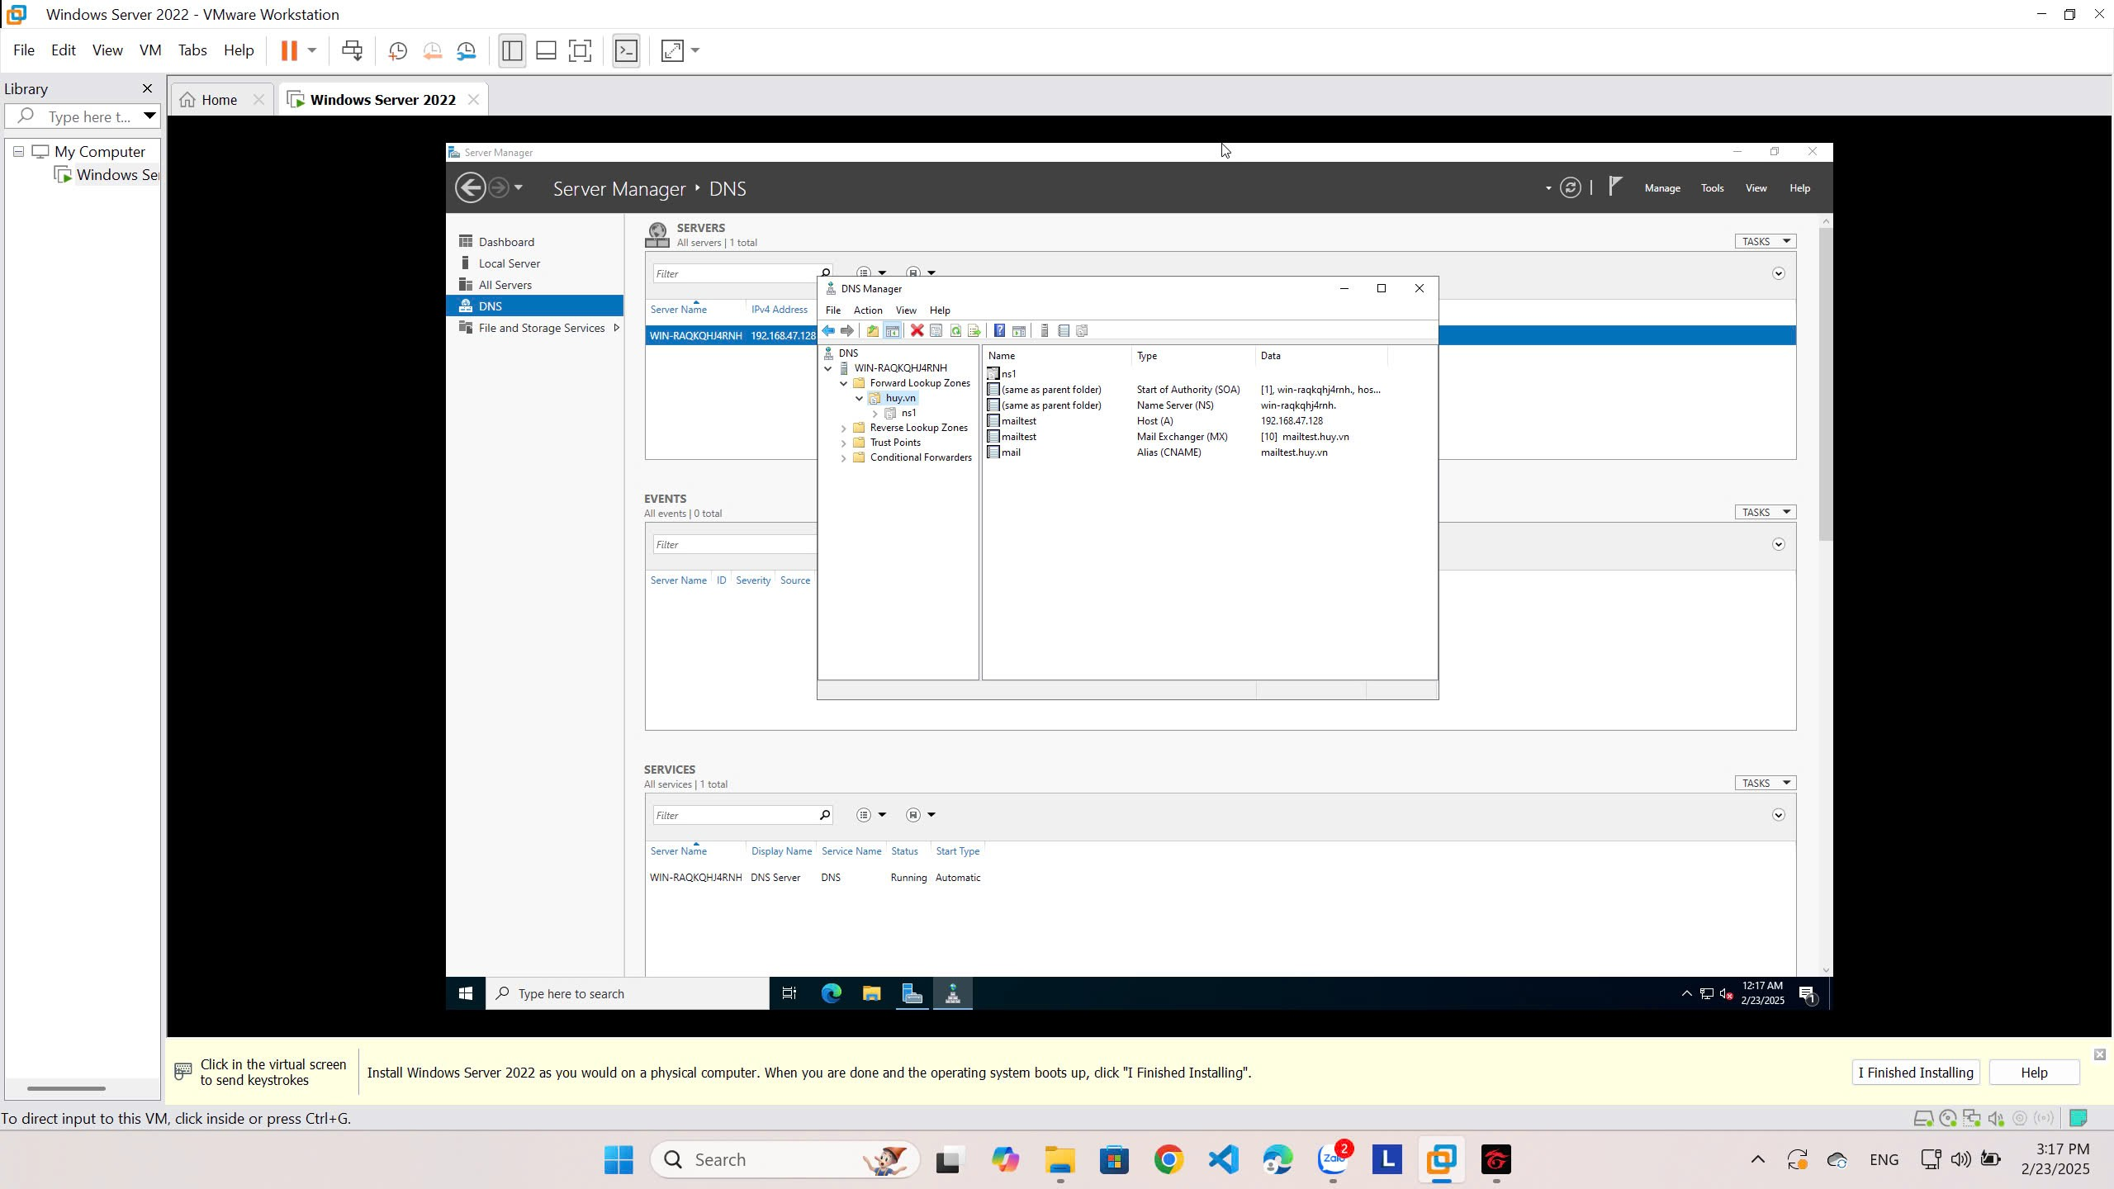

Password máy ảo: Huy09092004

PasswordDSRM: P@ssw0rd

**Promoting a Domain Controller**

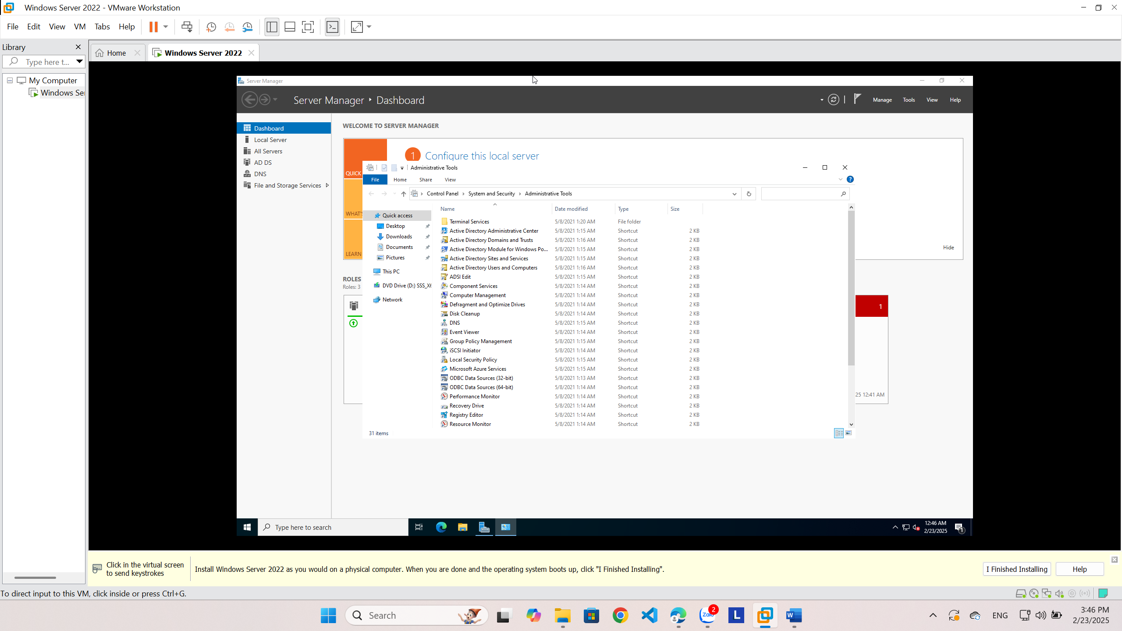

**Viewing the Active Directory Event Log**

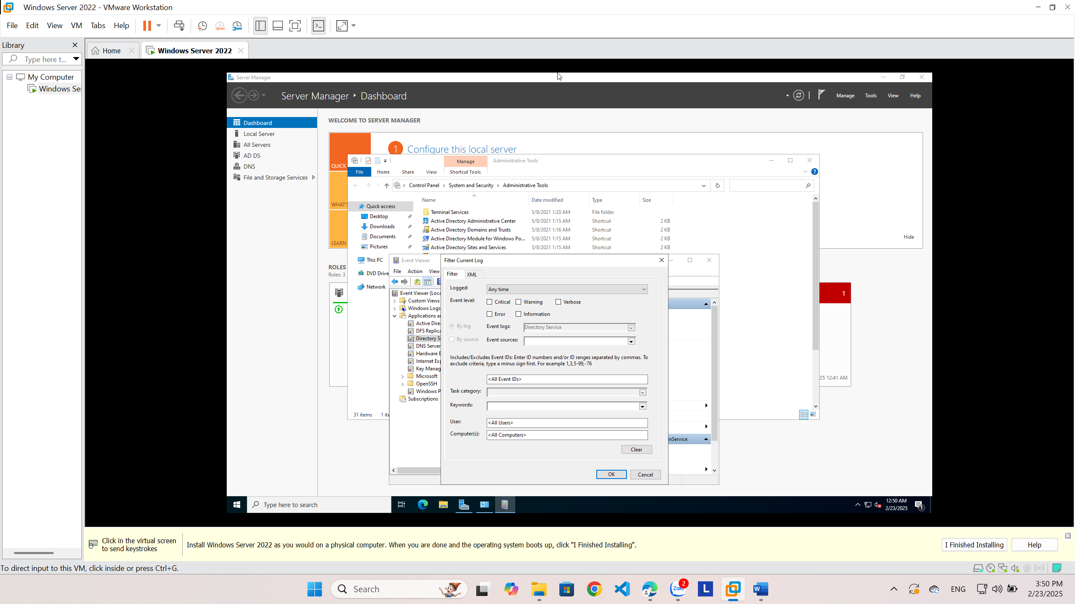

**Configuring DNS Integration with Active Directory**

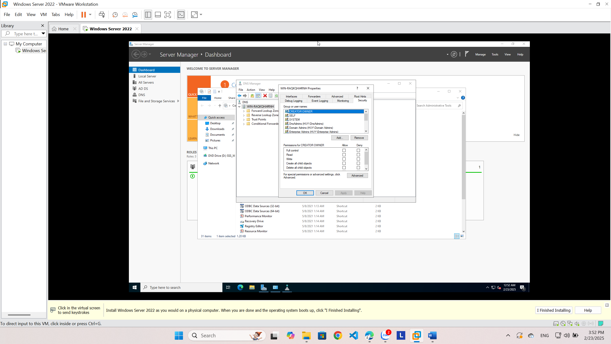

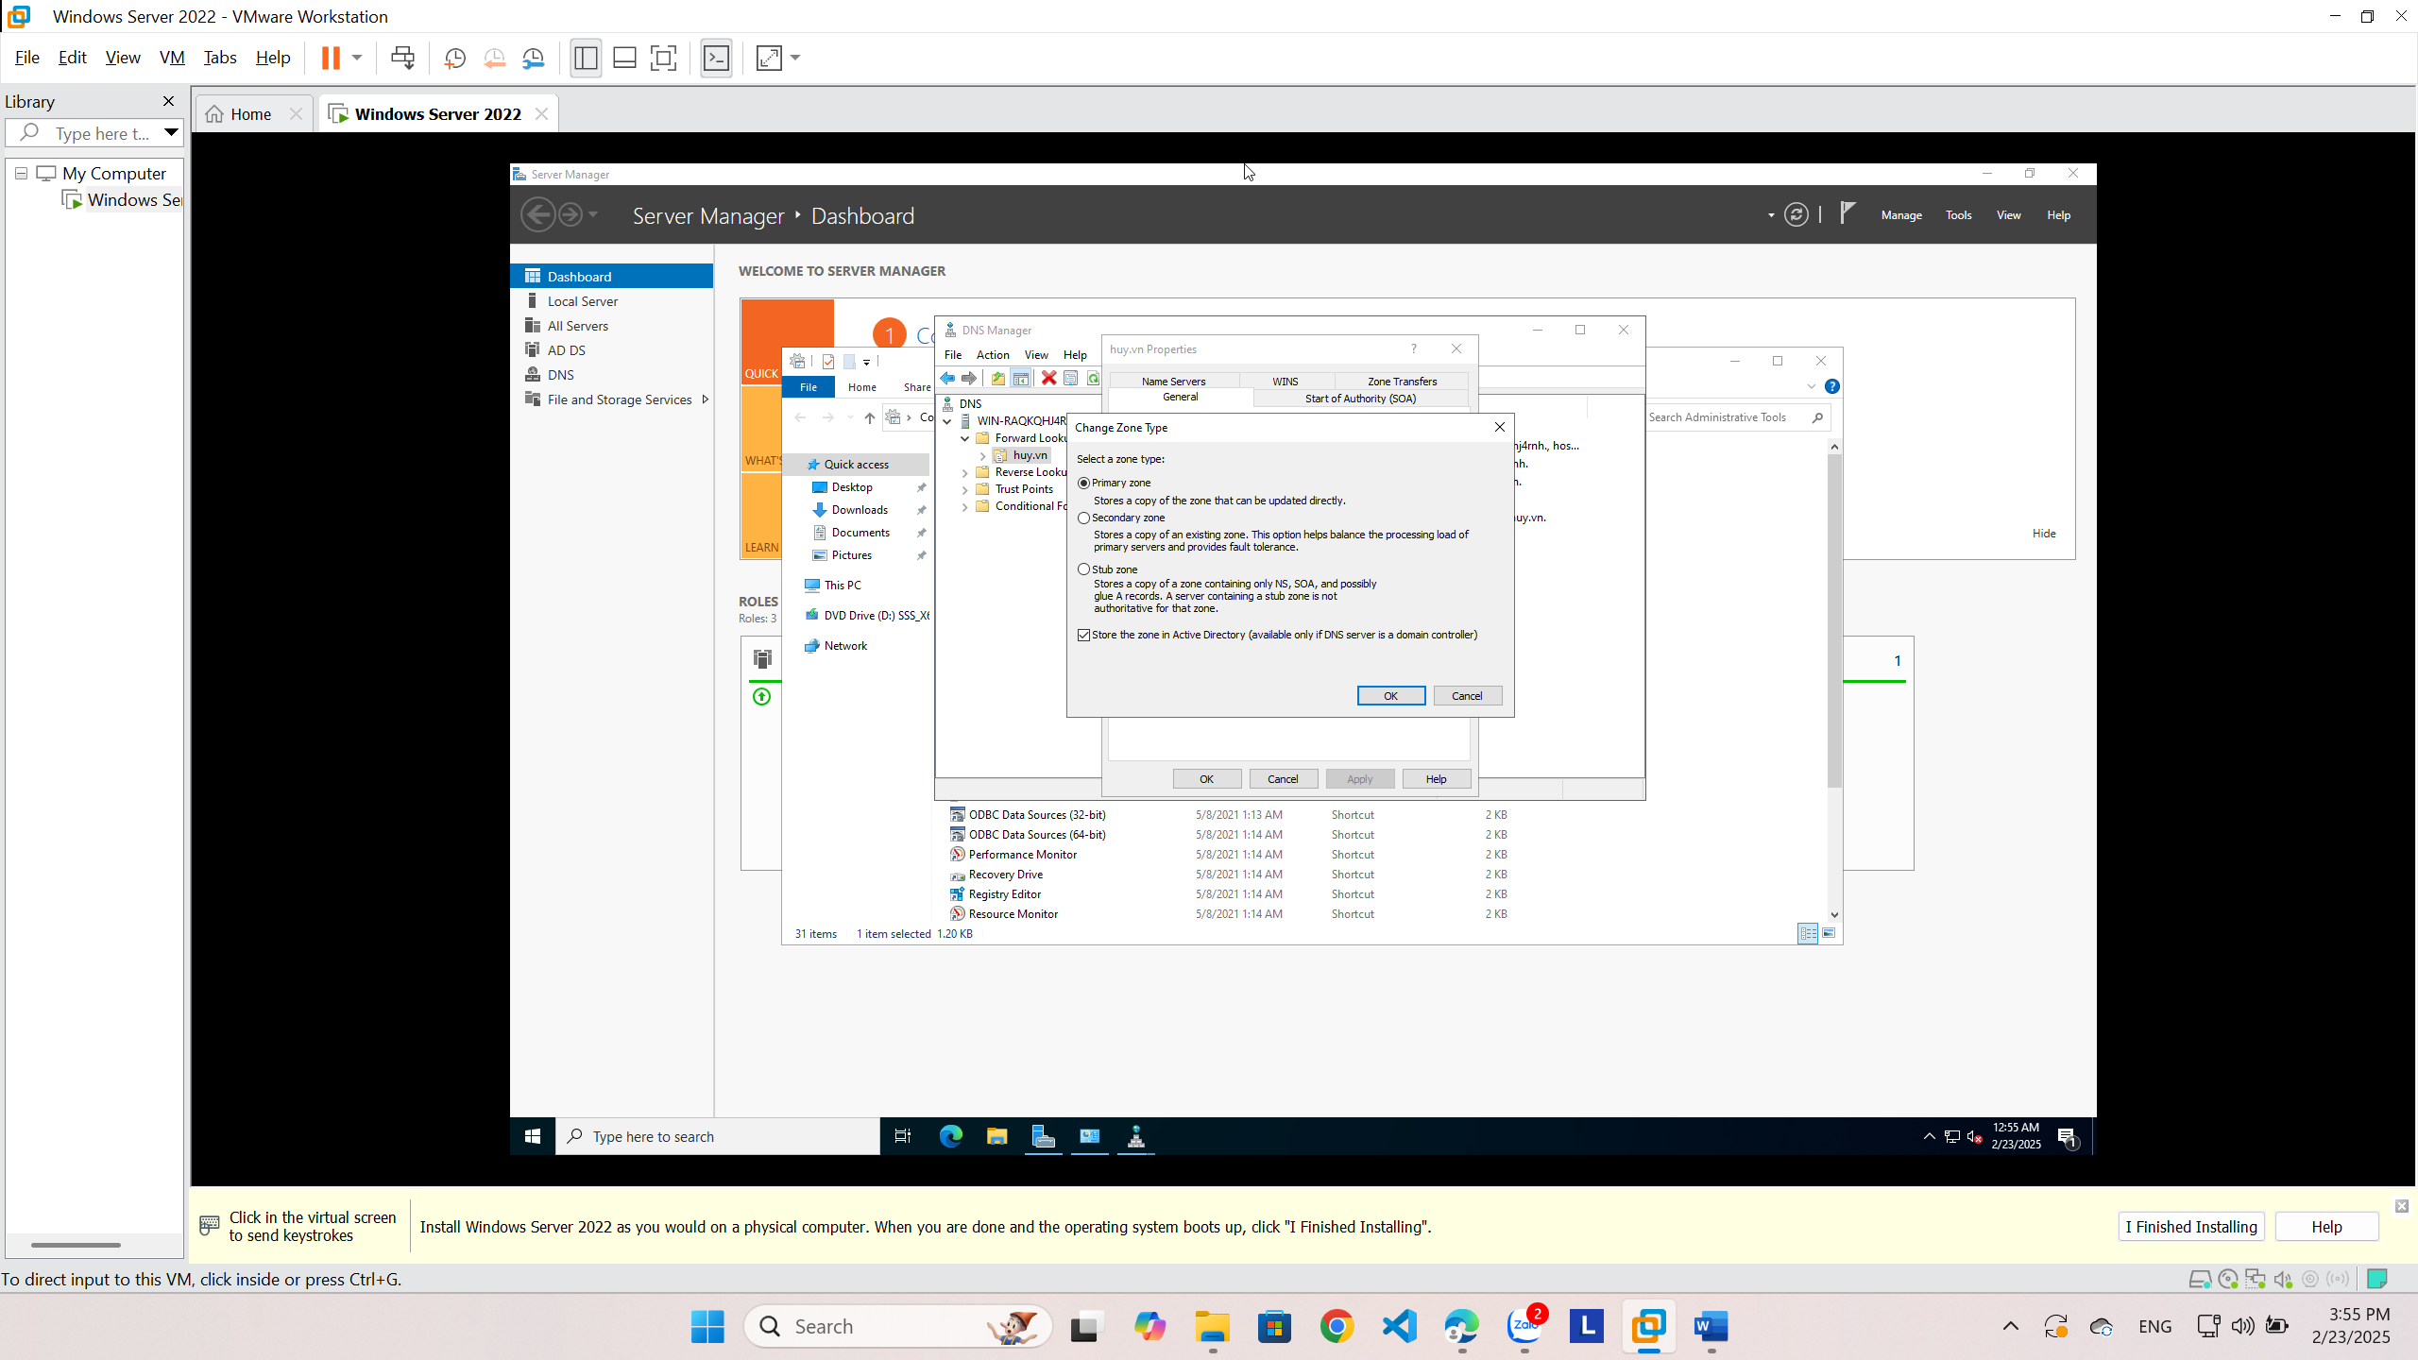

**Creating an OU Structure**

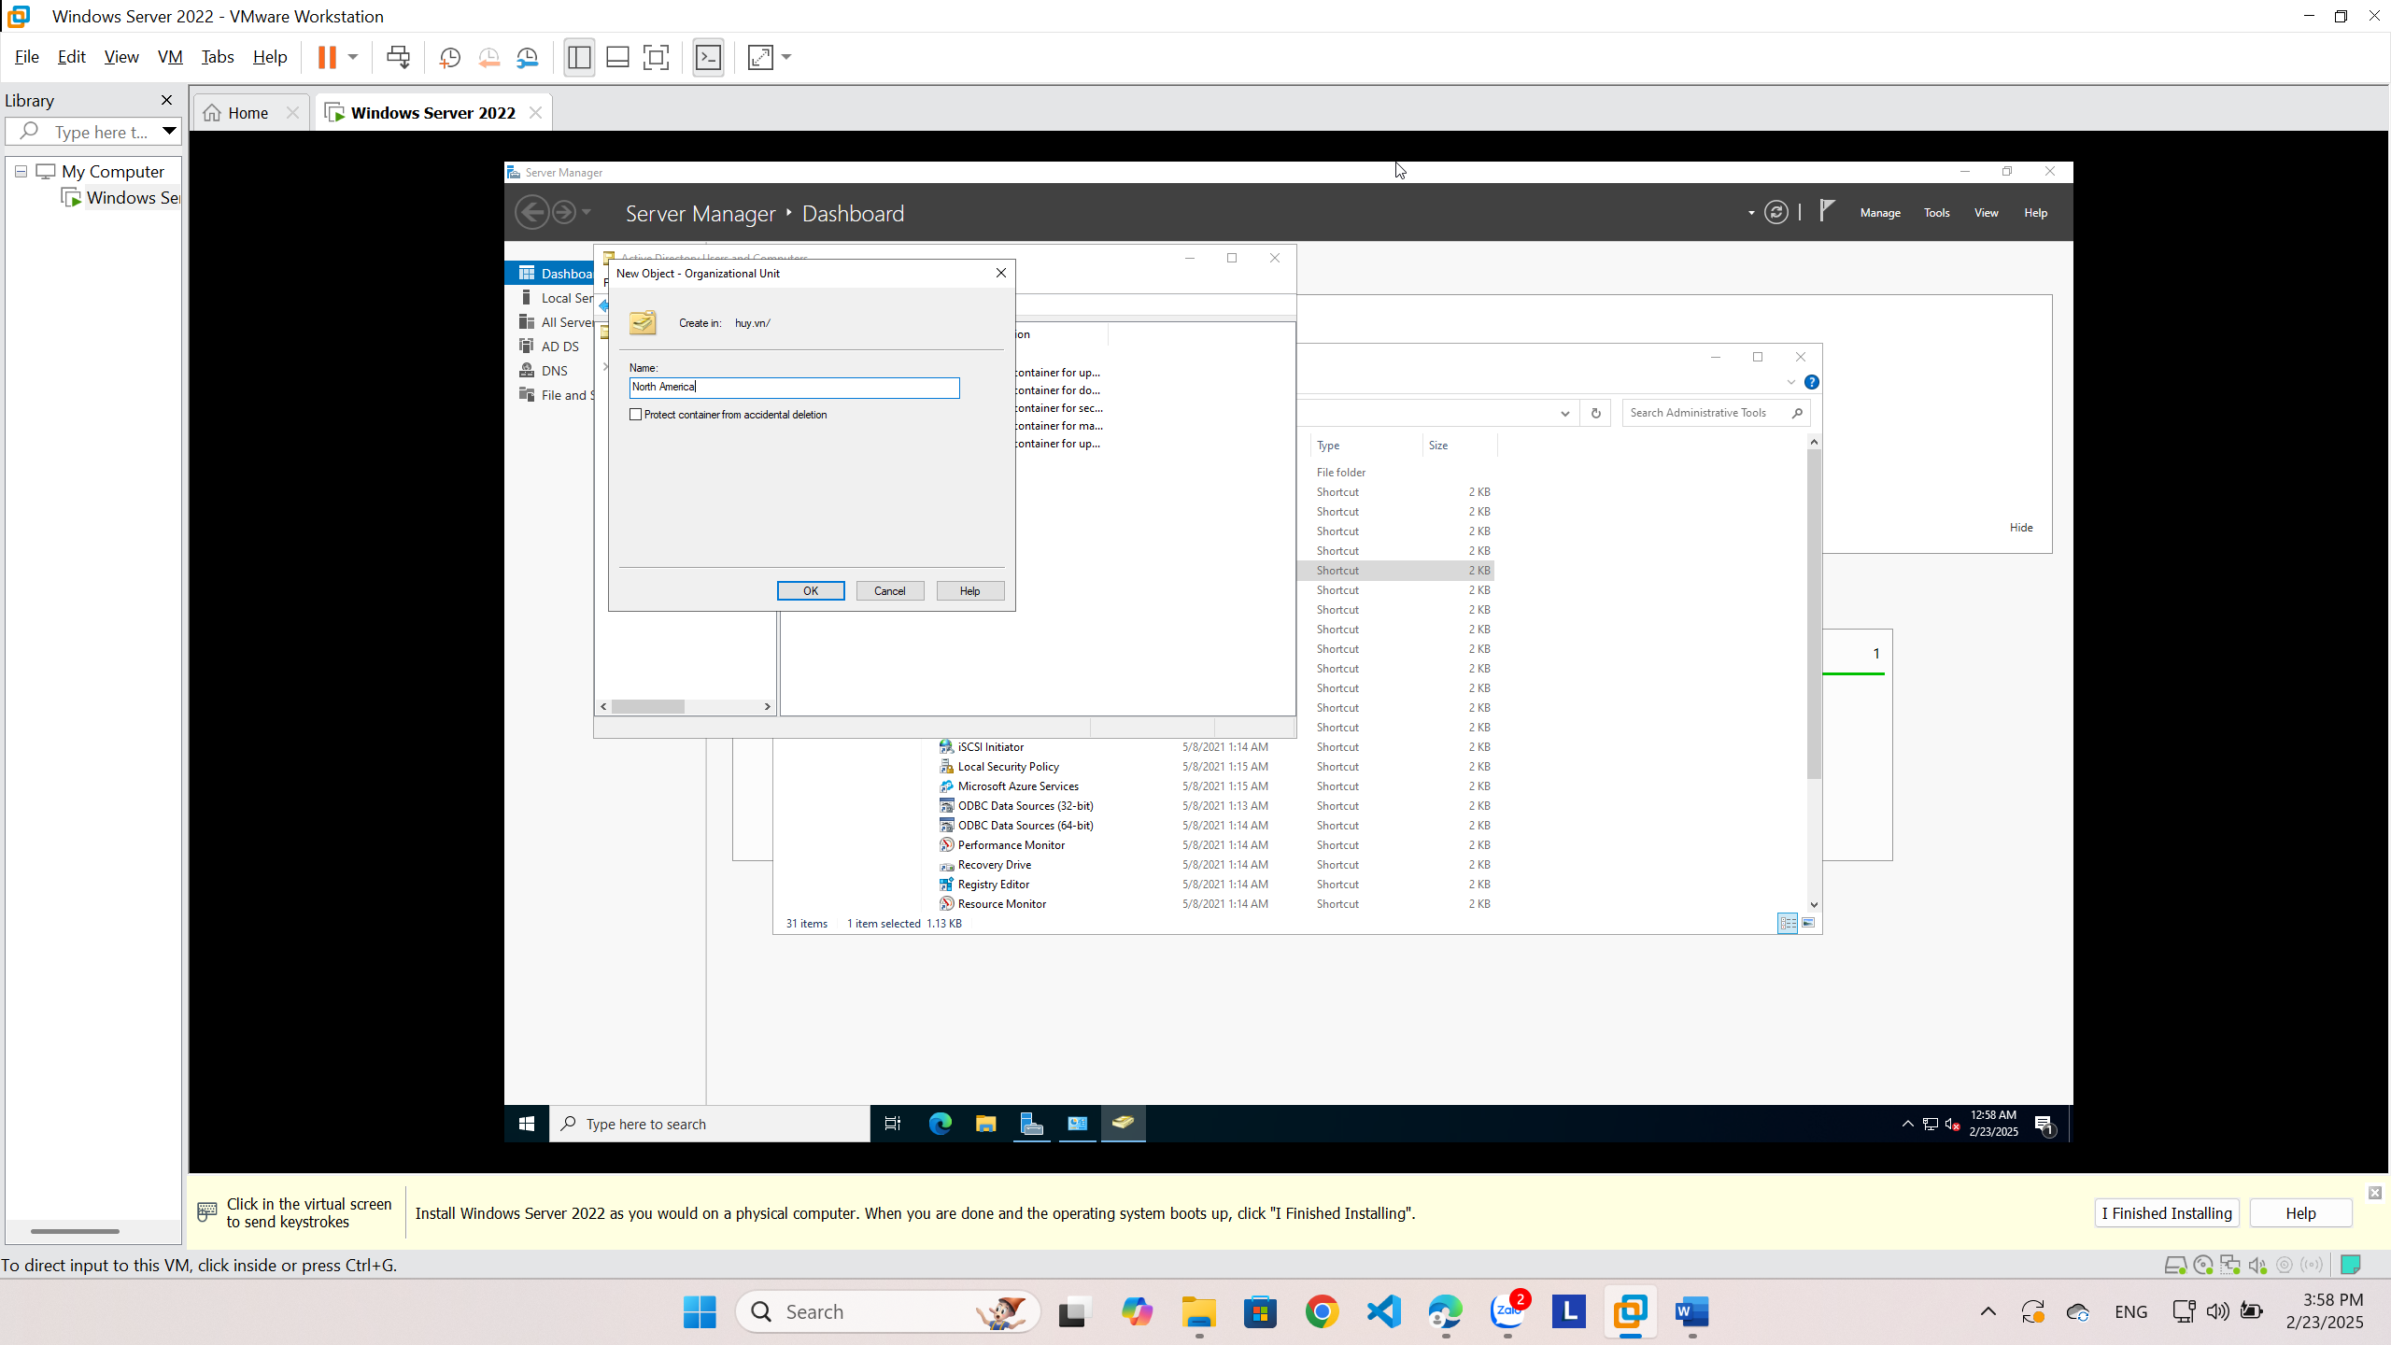

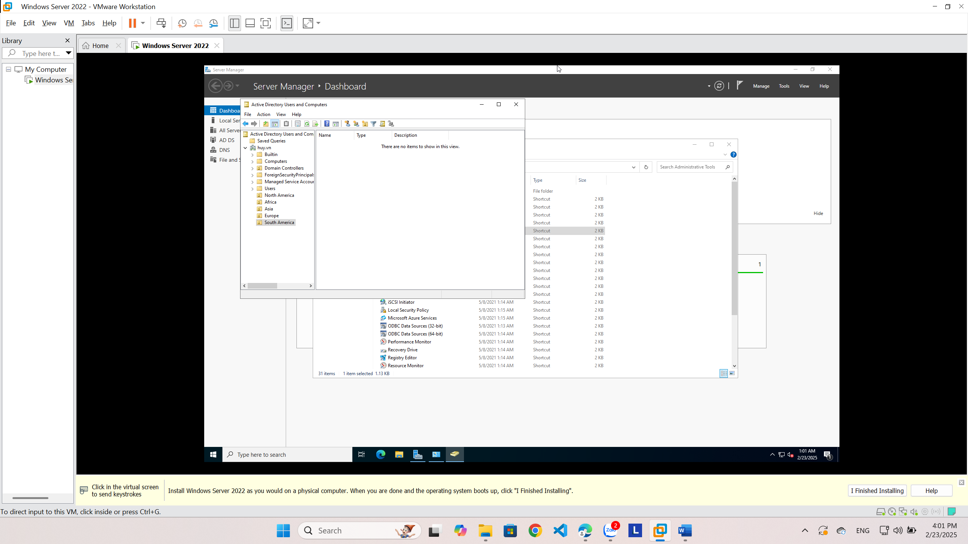

Buổi 3

**5.6. Creating an OU Structure**

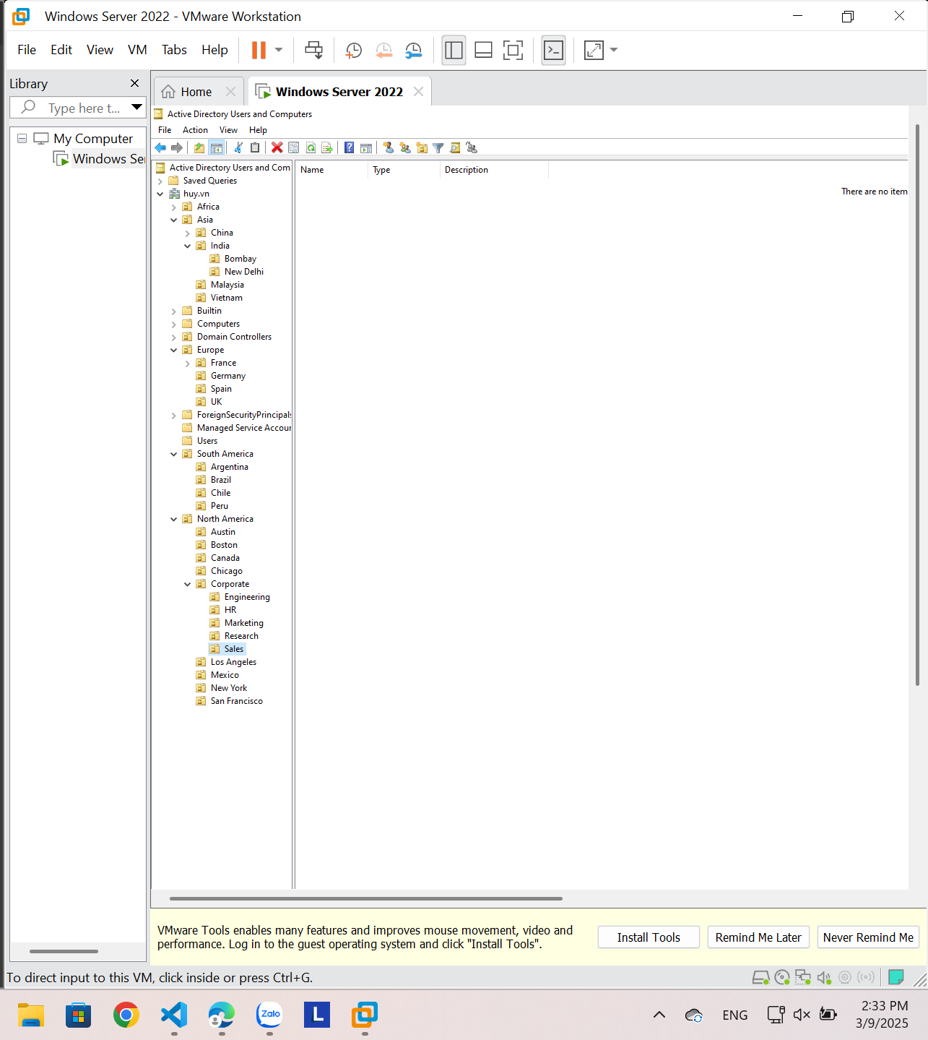

**5.7. Modifying OU Structure**

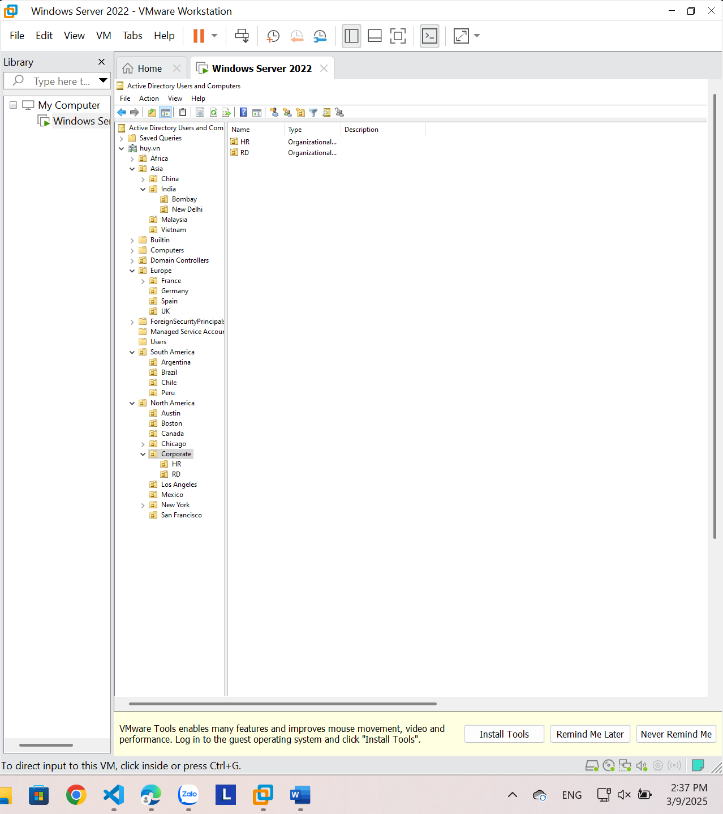

**5.8. Using the Delegation of Control Wizard**

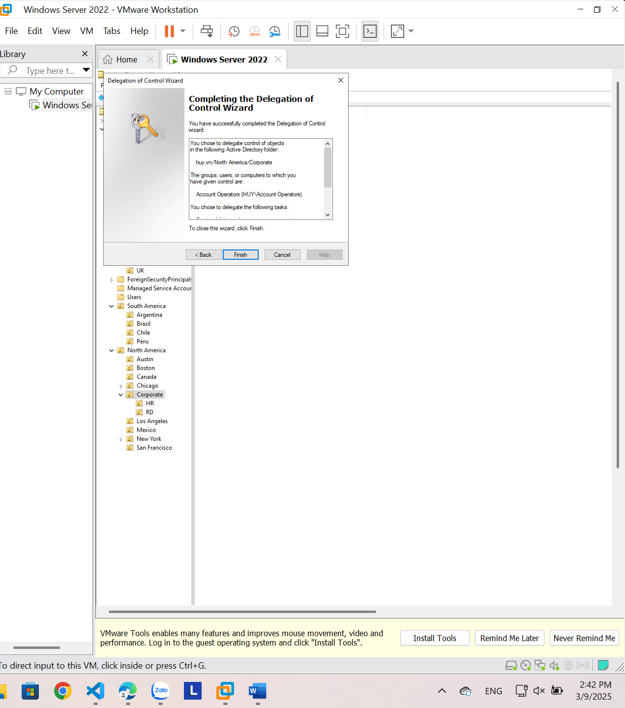

**5.9. Delegating Custom Tasks**

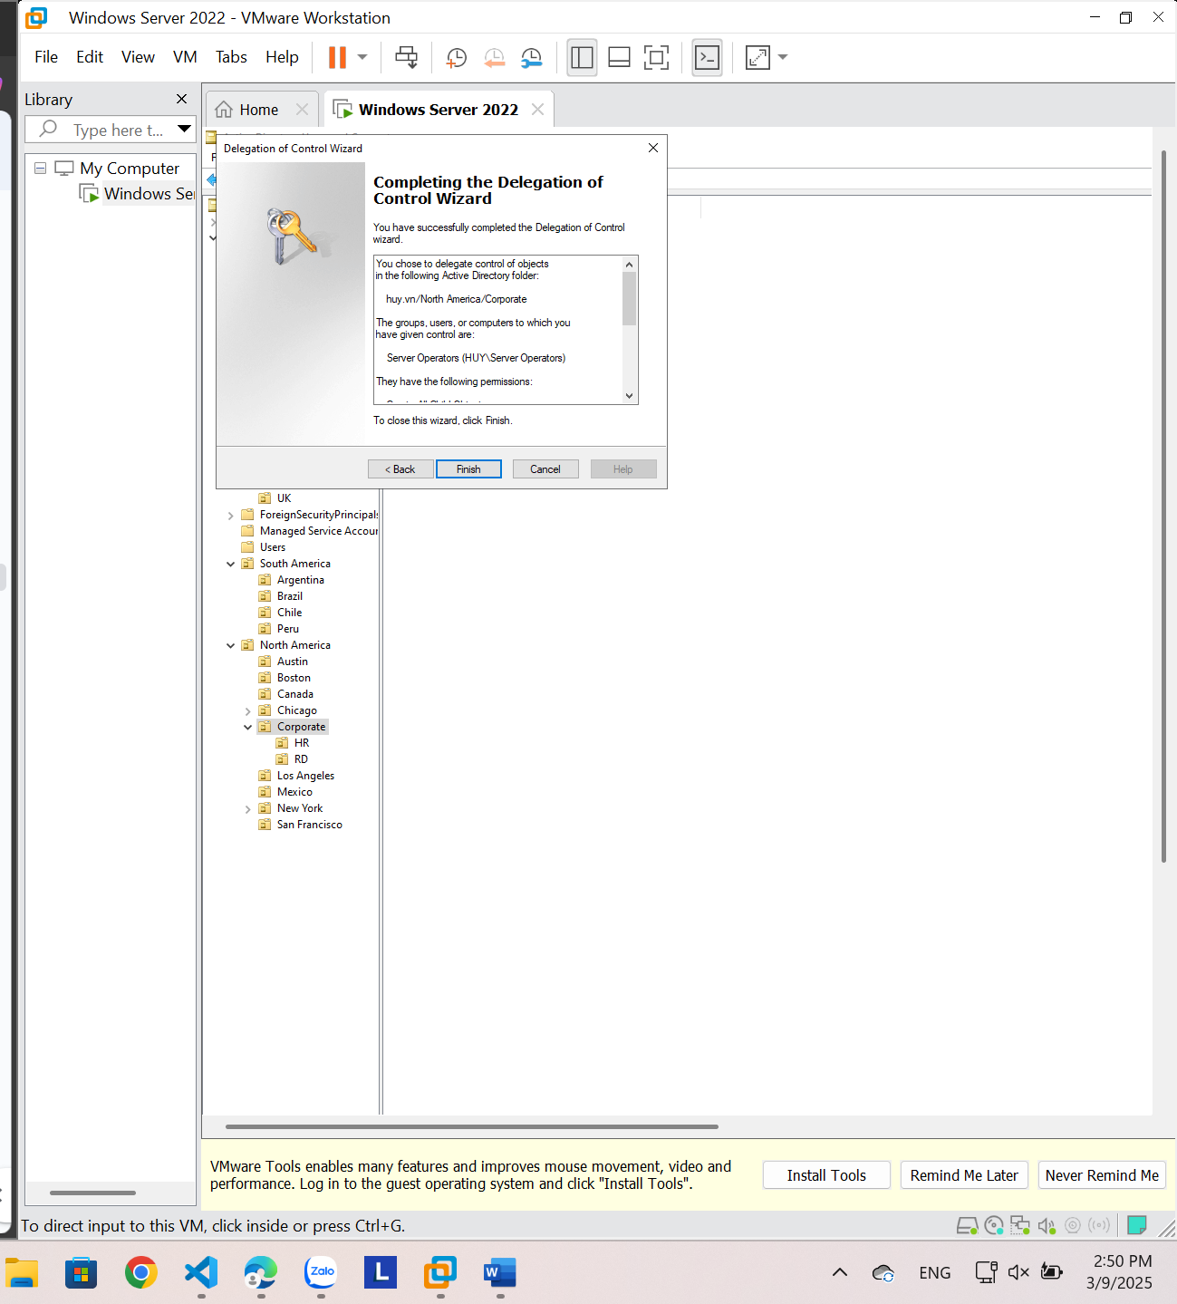

**5.10. Creating Active Directory Objects**

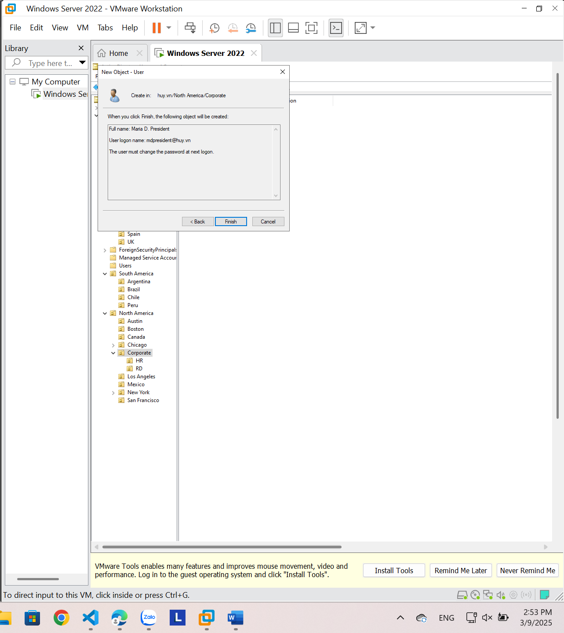

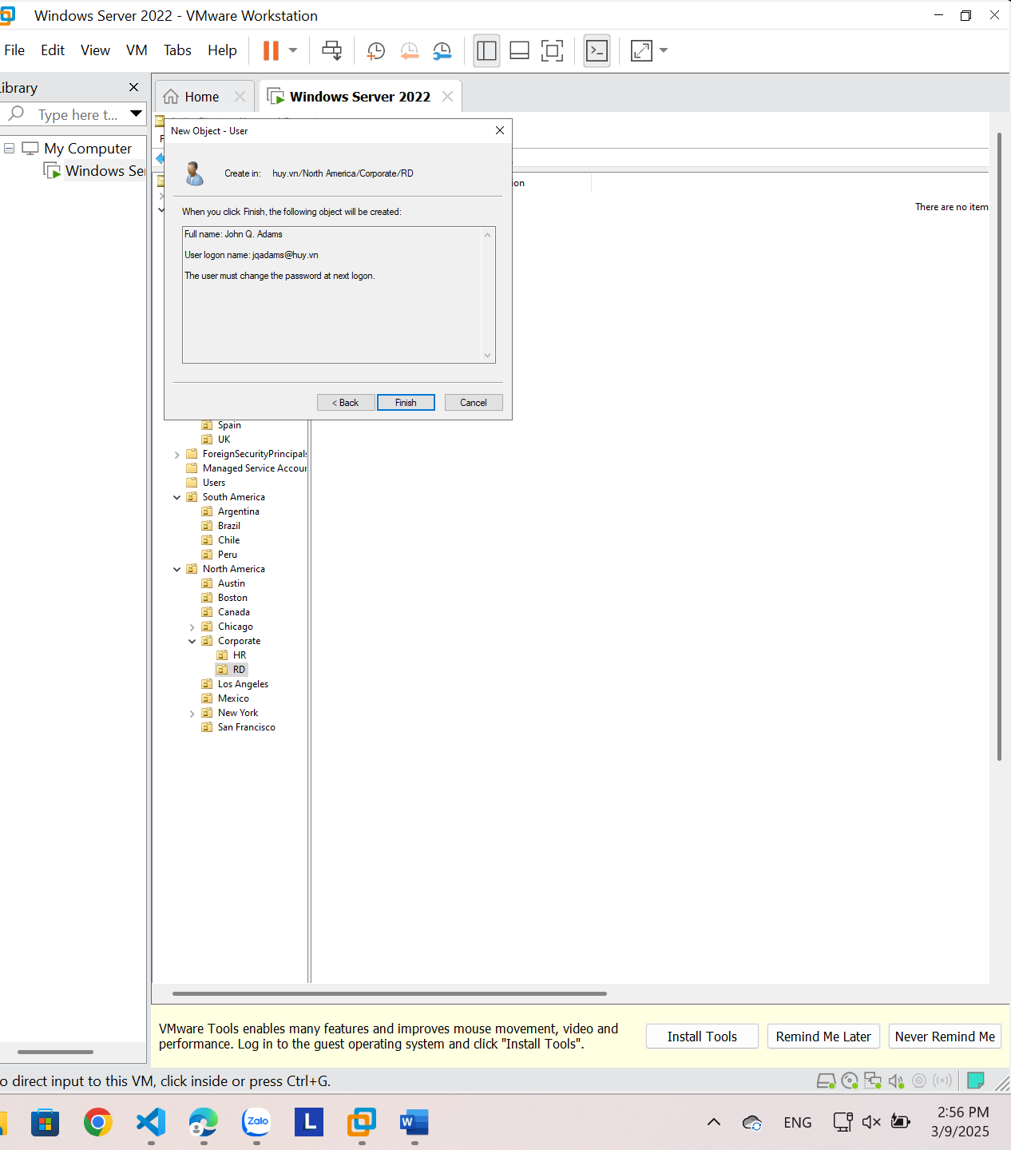

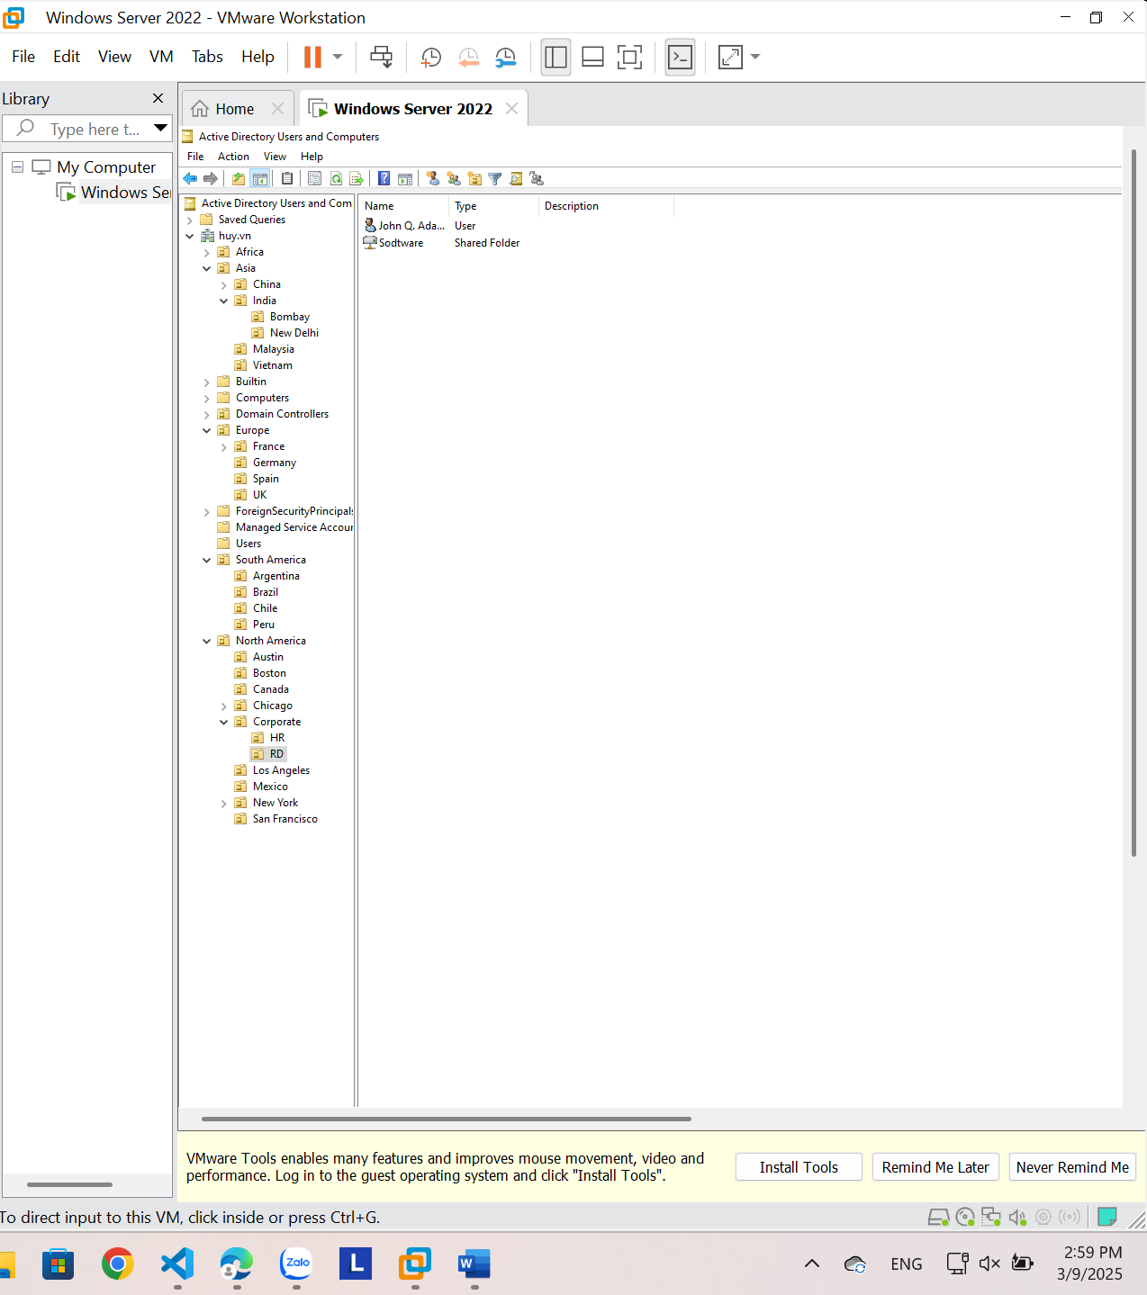

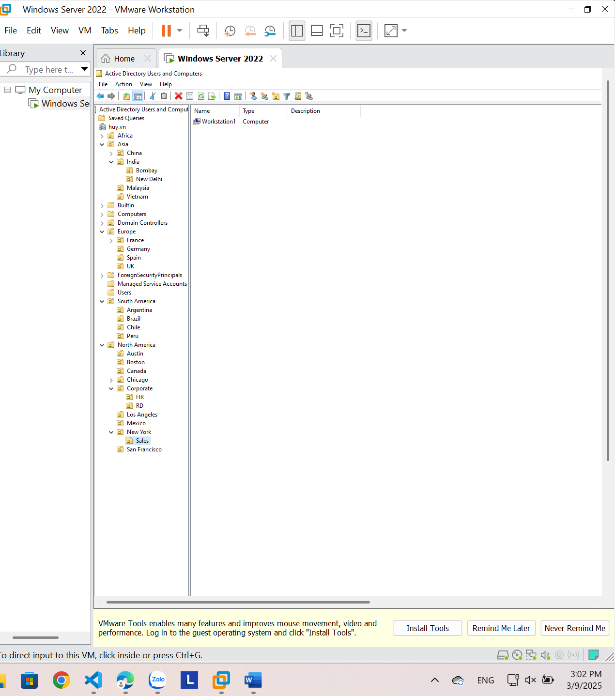

**5.11. Creating a User Template**

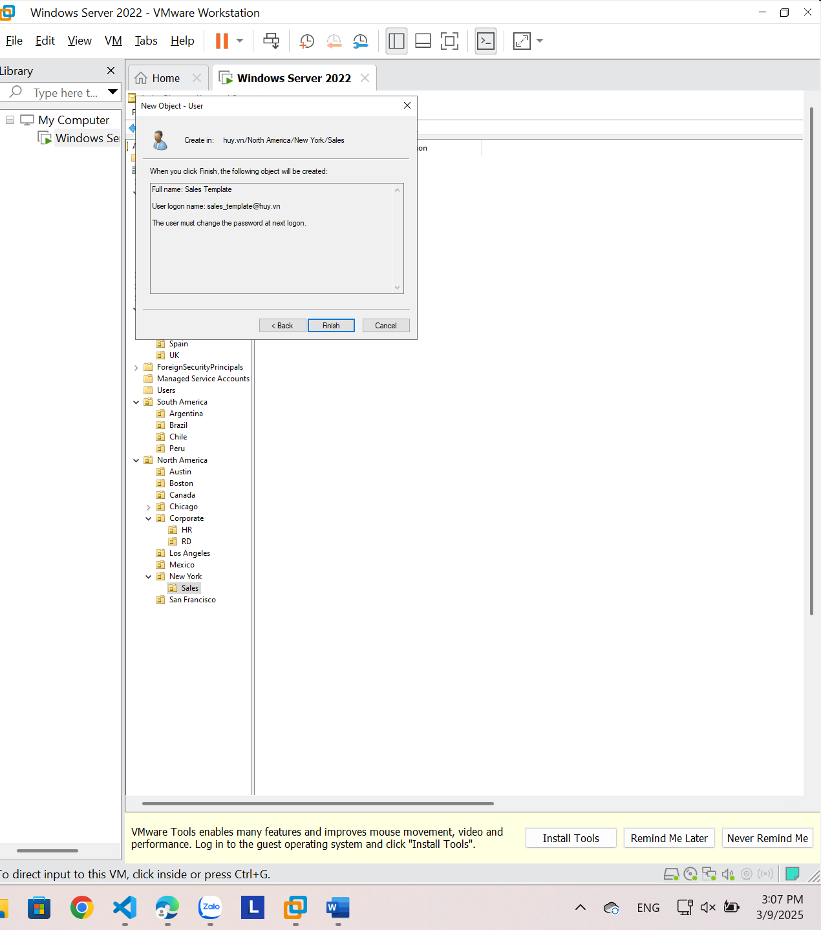

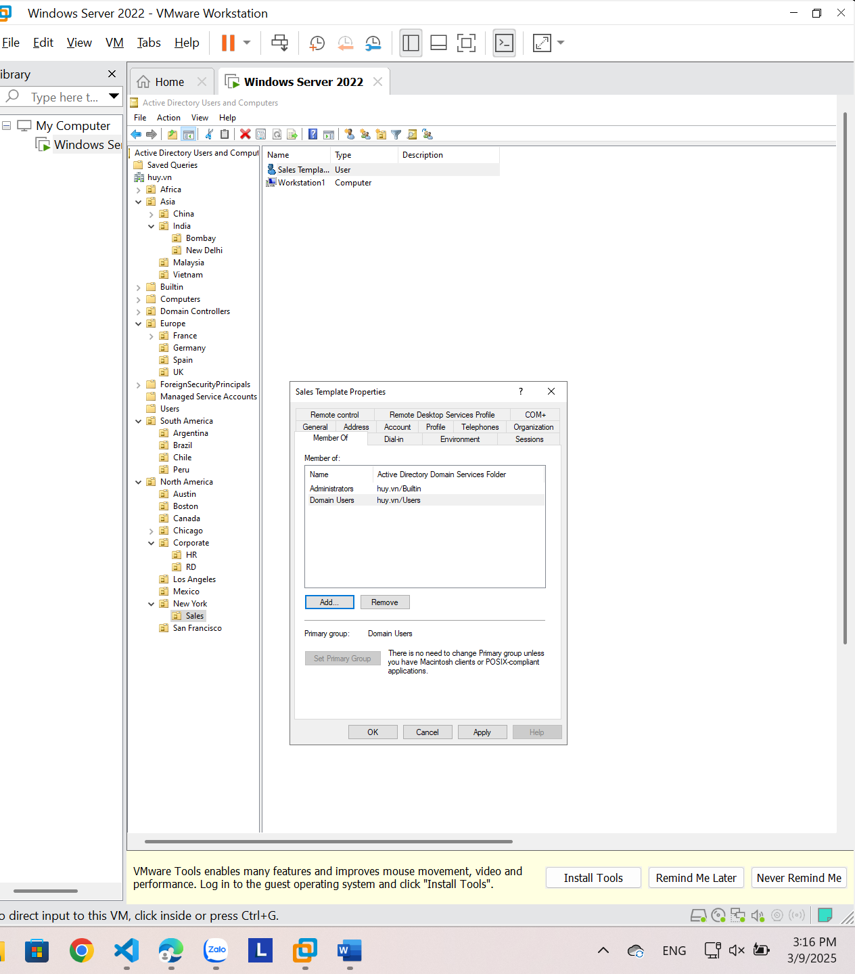

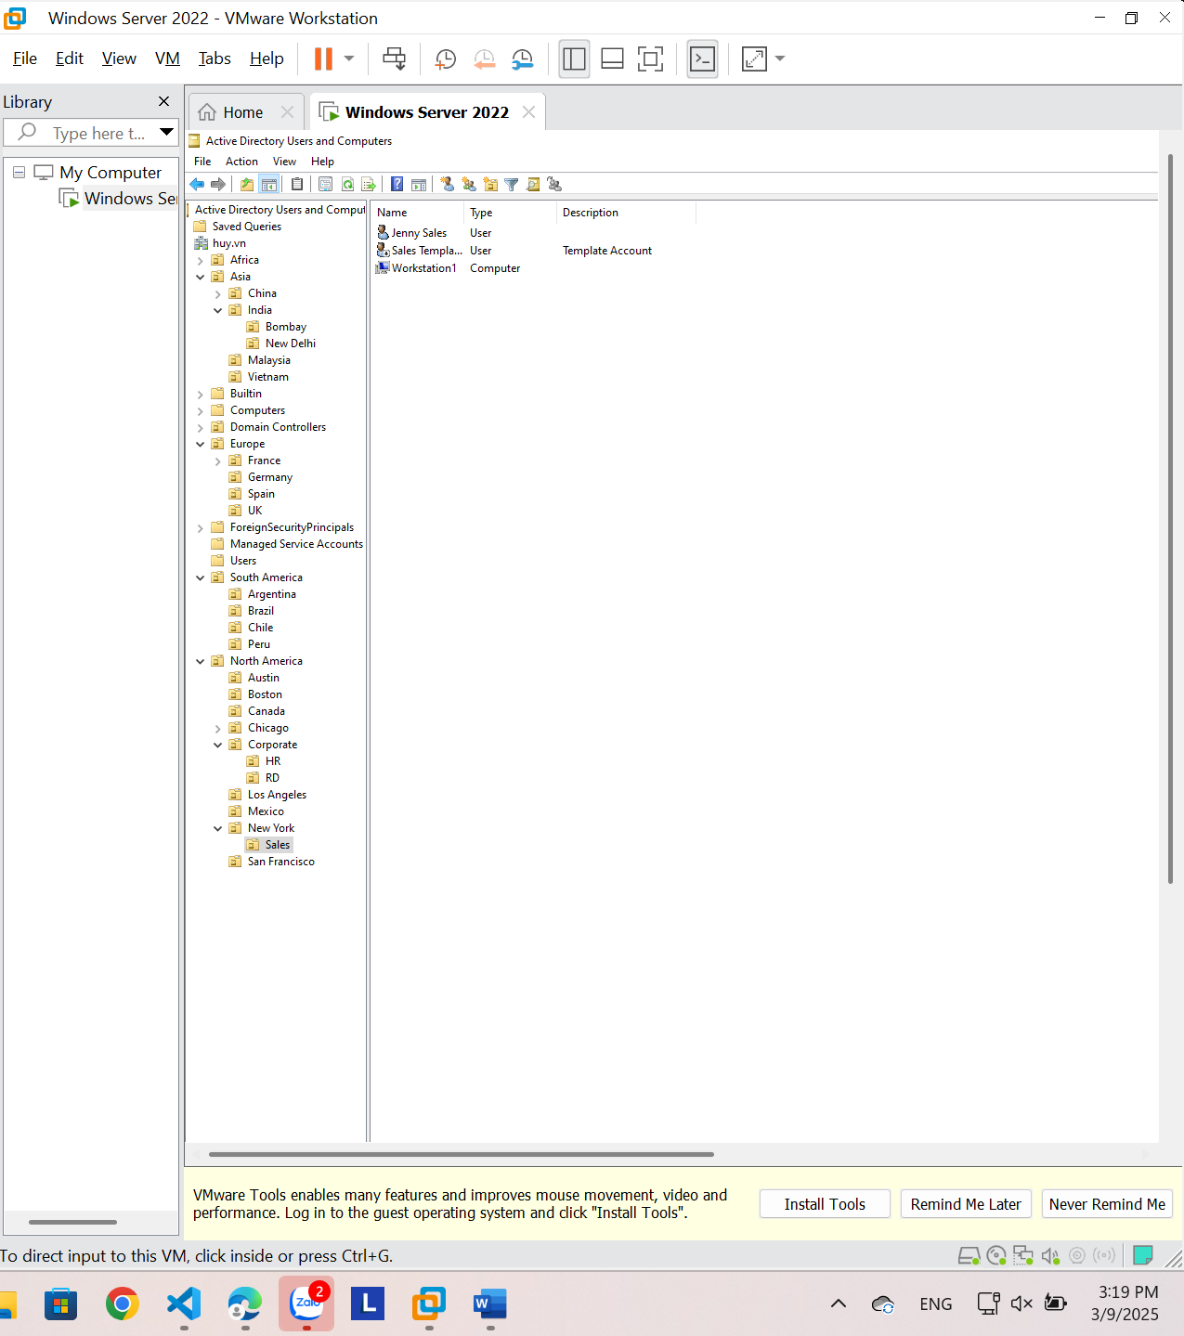

**5.12. Managing Object Properties**

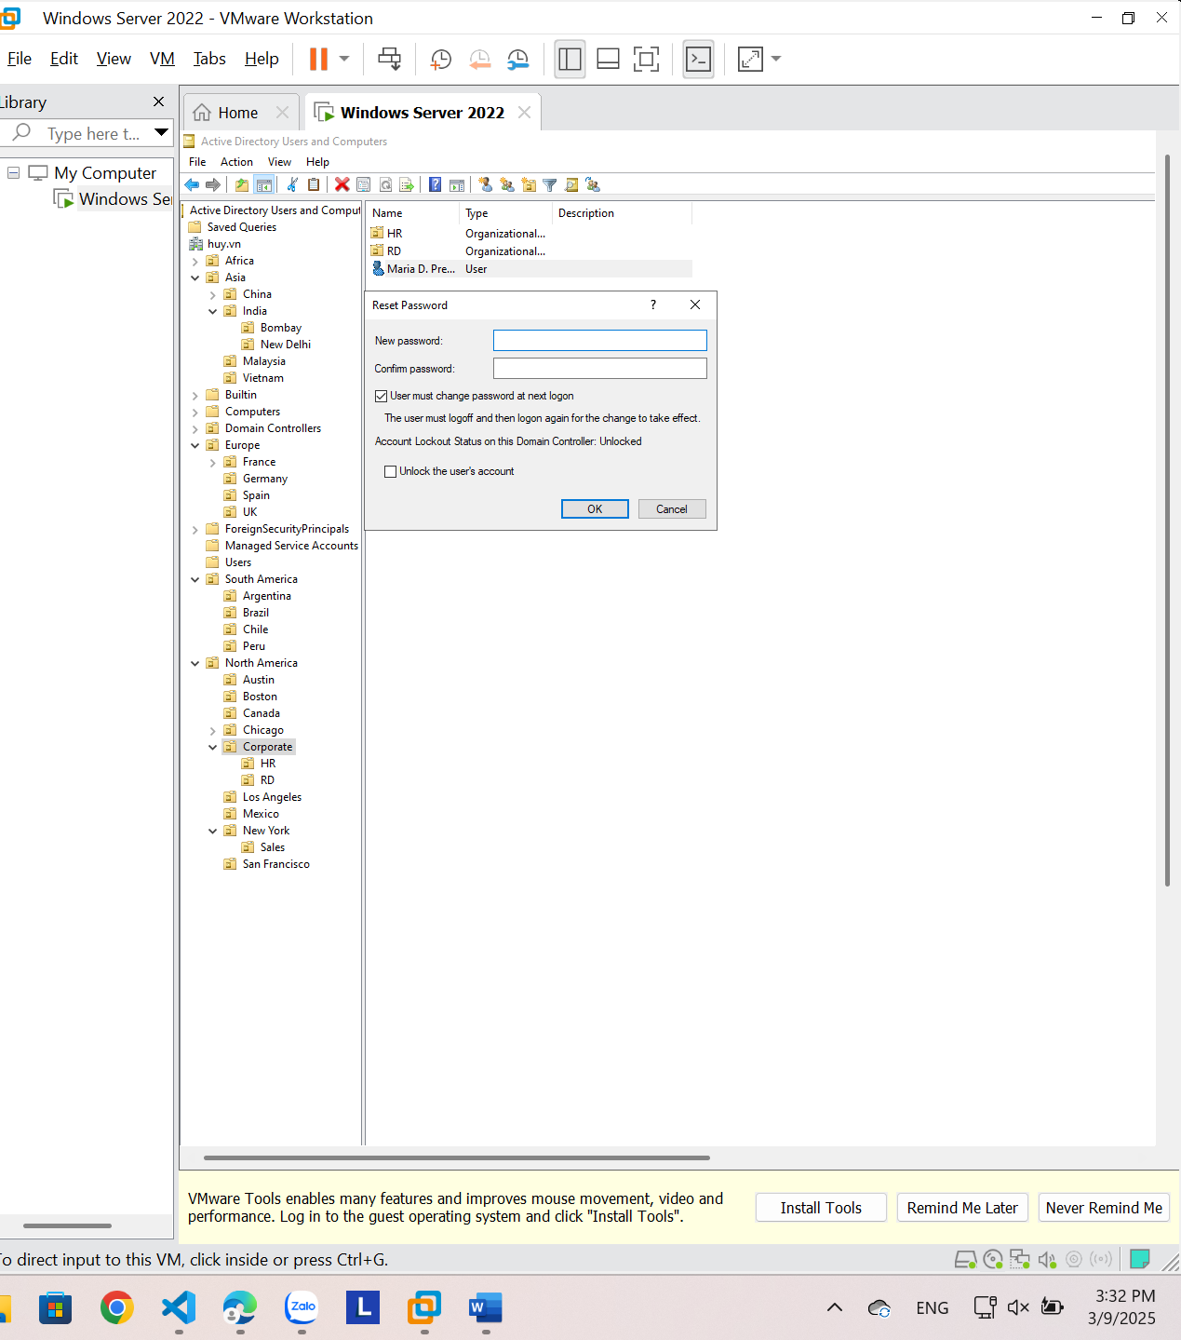

**5.13. Moving Active Directory Objects**

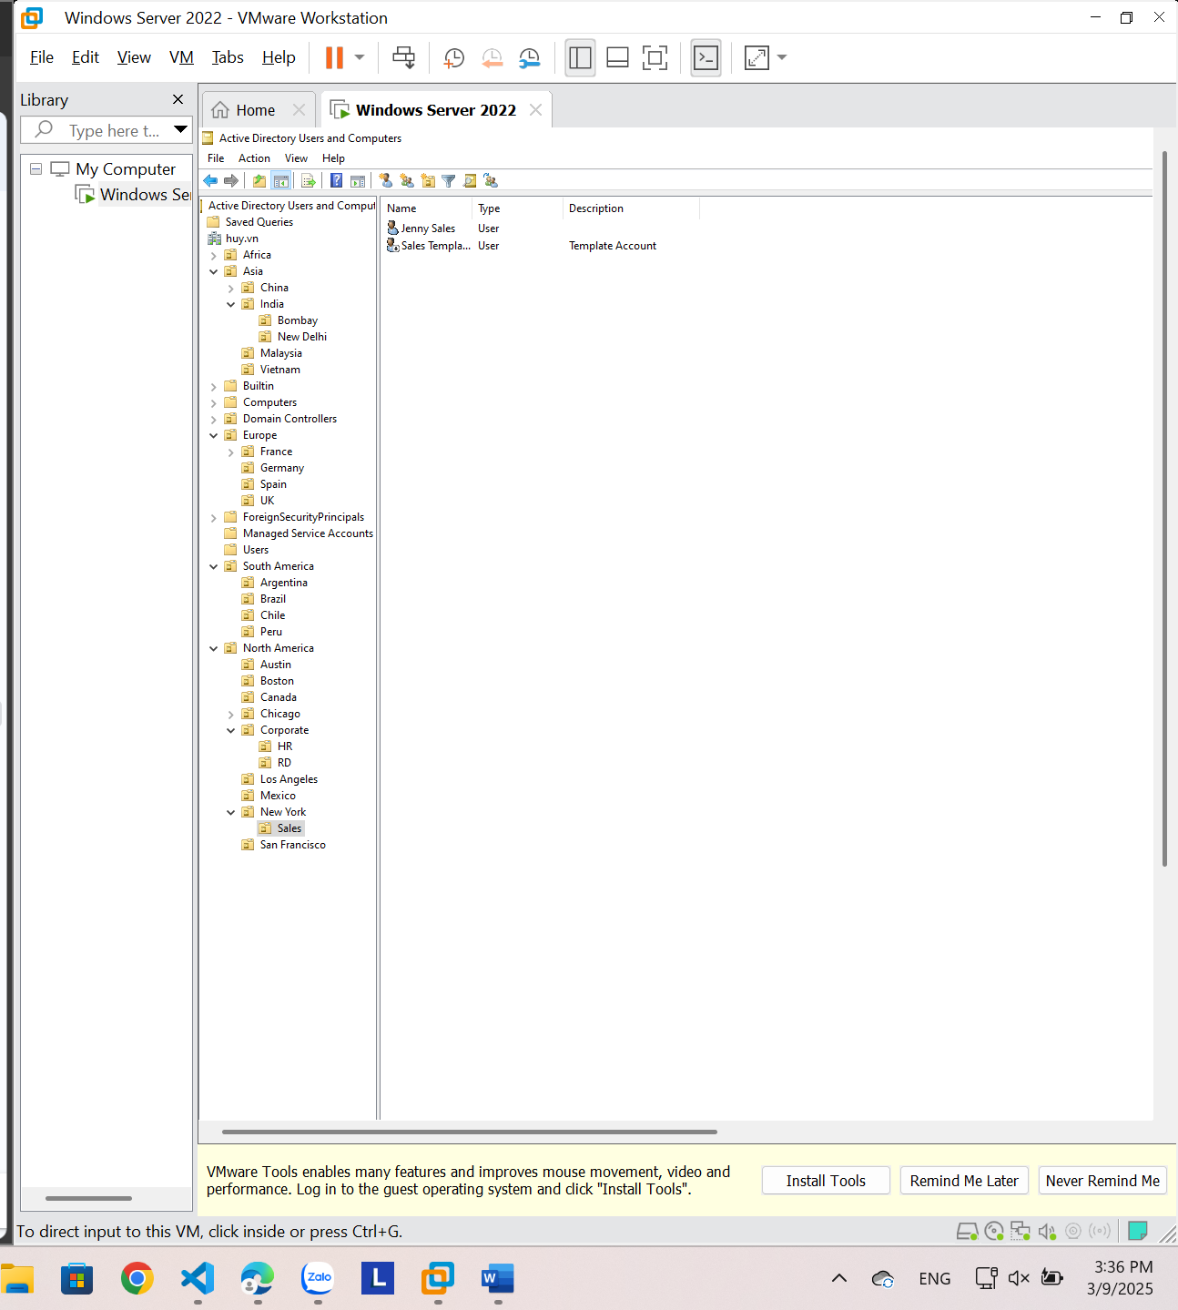

**5.14. Resetting an Existing Computer Account**

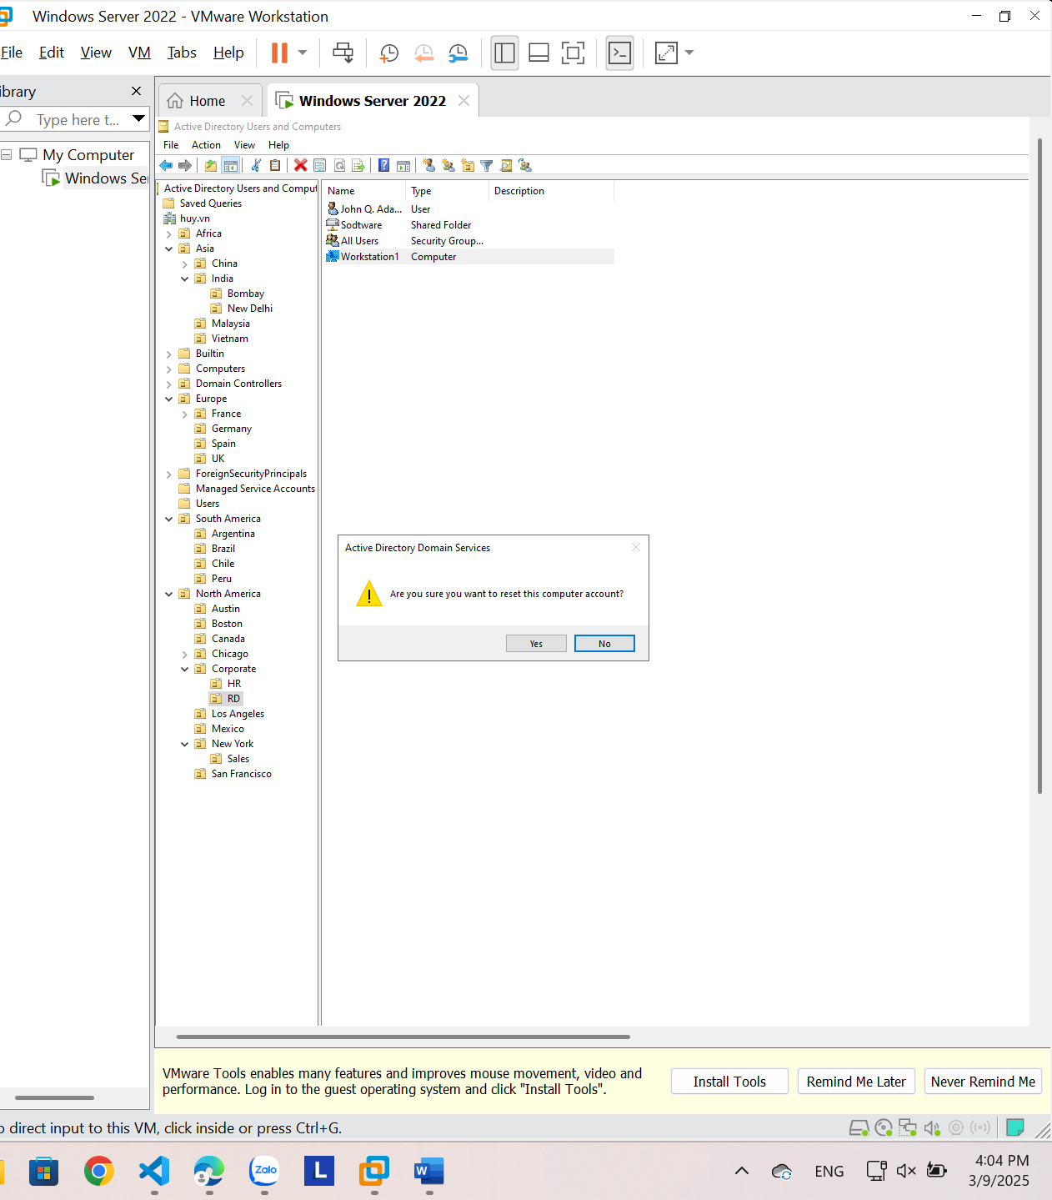

**5.16. Creating and Publishing a Shared Folder**

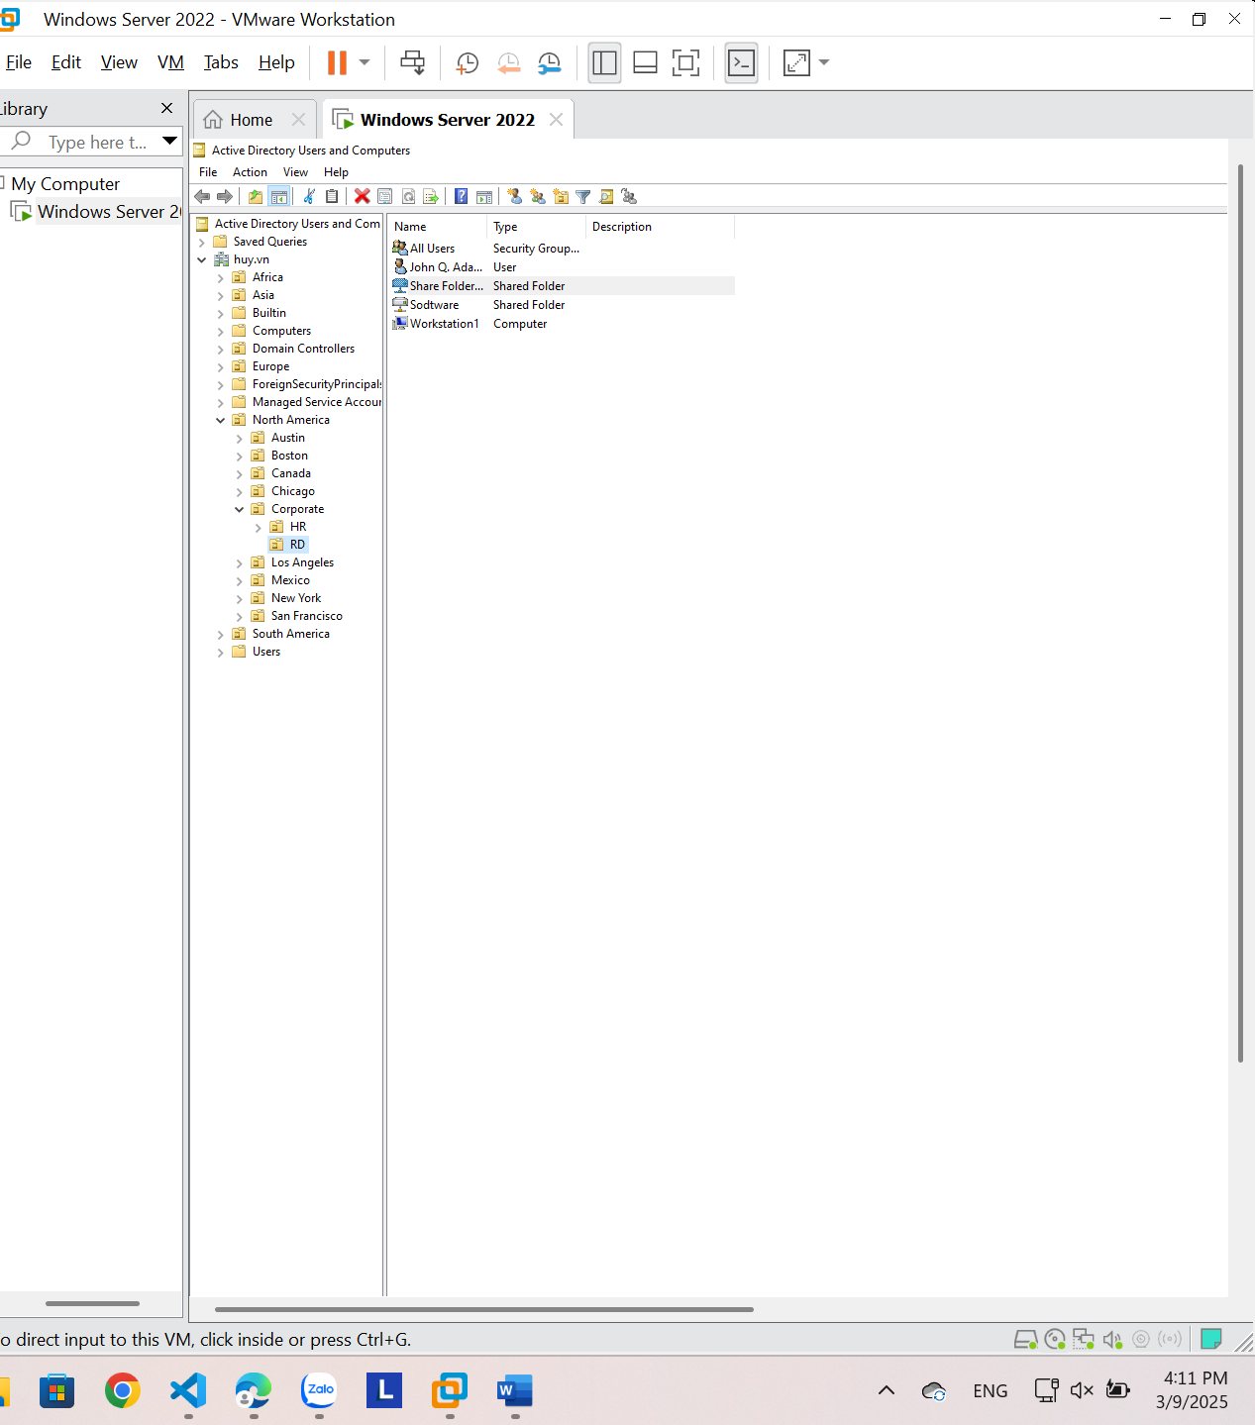

6. DHCP

**6.1. Installing the DHCP Service**

